Bloom Restoration Ministry
Matters of the Heart: Seminars and Workshops
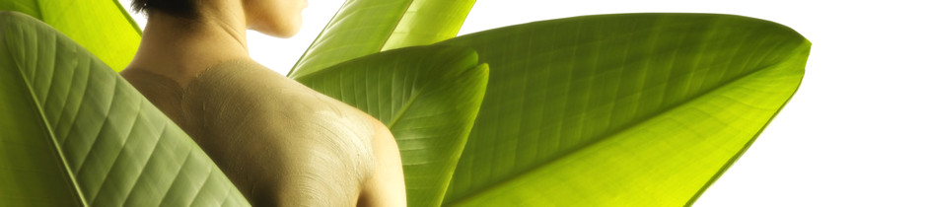
The workshops and seminars offered by Bloom Counseling complement our counseling efforts which aim to bring healing and restoration to all that seek it, enabling people to walk in abundance and power.
(John 10:10)
*Note: Seminar and Workshop themes are interchangeable

Creating healthy Boundaries-Workshop
People have good intentions of being loving, giving, and selfless, but often enough we forget our limitations as human beings. This workshop helps us create and maintain clear boundaries that help us lead a healthy and balanced life.
Making Peace with Our Past-Workshop
This workshop helps us to identify how our past affects us today. Dysfunctional families, negative childhood upbringing, traumas and past life events may lead children to bury feelings and emotions that damage their self-worth when they become adults. In this workshop we identify some of these damages and how they are leading us to live a life that is less than what God intends.
The Lies We Believe-Workshop
In this workshop we understand what lies we believe that are damaging our lives and what to do about them. We look at the misery these lies cause us and learn the freedom that comes from the truth.

Heart to Heart Relationships-Workshop
This workshop covers how to relate from the center of our hearts- the place where God powered His love in us. We discuss such aspects as kindness, becoming a good heart-centered listener, celebrating people’s success, taking responsibility of our own actions, and removing the expectations that people must change before we love them.
Living From Our True Identity-Workshop
When we know and believe our value and identity in Christ-- then and only then are we able to receive and walk in God’s blessings and experience abundant life. Many people today are depressed, anxious and going through various emotions because they do not know who they are. This workshop helps us to understand the whole person-the harmony of the spirit, the soul and the body; how to prosper from the soul while living in healthy bodies. “We are Spirit being, living in a body and possessing a soul.”

Emotionally Healthy Spirituality
In this seminar we learn about our being: Spirit, soul and body and how God intends us to integrate and harmonize our being to live victoriously. Unfortunately so many people are ruled by their emotions and this is a direct cause of the dysfunction we are witnessing in Church. We discuss signs of emotionally unhealthy/healthy spirituality
Being Like a Tree-Seminar Series
These series of workshops and seminars cover various topics from Dr. Jane Wamucii’s book The Blooming Woman- Growing the King’s Divine Tree, 2012. Using the analogy of the tree described in Psalm 1:1-3, she discusses various processes that go into growing a tree that produces fruit. These processes include: preparation of the soil, creating the right environment, creating strong roots, protecting the tree with prayer, and feeding the tree with the truth and developing balanced branches.

College Preparation Workshop
Bloom counselling student consultants that have made it to top American Universities offer advice on how to prepare for prepare for college. Presentation include overview of college application, how to get scholarships and much more. The workshop is for both parents and their youth

